EXPT NO:5 | DEVELOP INTERACTIVE DASHBOARDS FOR DYNAMIC DATA EXPLORATION USING TABLEAU AND POWERBI
DATE: 24.07.2026

PRE-LAB QUESTIONS (PROVIDE BRIEF ANSWERS TO THE FOLLOWING QUESTIONS)
- What is dynamic data exploration in BI tools, and why is it important?
Dynamic data exploration allows users to interact with data using filters, slicers, and drill-down features. It helps users analyze data from different perspectives and make better decisions.

- What are slicers and filters, and how do they enhance dashboard interactivity?
Slicers and filters allow users to display only the required data. They make dashboards interactive by enabling quick analysis based on categories, regions, dates, or other fields.

- How do Tableau and Power BI support drill-down and drill-through features?
Tableau uses hierarchies to drill down into detailed data. Power BI supports drill-down within visuals and drill-through pages to view detailed information for selected data.

- What is the role of parameters in creating interactive dashboards?
Parameters allow users to change values or switch between different measures and visualizations. They make dashboards more flexible and interactive.

- Name some advanced interactivity features in Tableau and Power BI.
- Filters and Slicers
- Drill-down and Drill-through
- Parameters
- Tooltips
- Bookmarks
- Highlight Actions
- Cross-filtering
- Cross-highlighting

IN-LAB EXERCISE:
OBJECTIVE:
To design and develop interactive dashboards in Tableau and Power BI for dynamic data exploration, enabling users to analyze, filter, and drill down into data for deeper insights.
PROCEDURE:
- Data Collection:
    - Import datasets from sources such as Excel, CSV, SQL Server, or online APIs.
    - Dataset: Retail Sales Dataset with fields such as Order Date, Region, Product Category, Sales, Profit, Quantity.
- Data Preparation and Transformation:
    - Ensure proper date formats for time-based analysis. o Handle missing or incorrect values.
    - Create calculated fields (e.g., Profit Margin %, Sales Growth %, Year-to-Date Sales).
- Data Aggregation and Hierarchies:
    - Create hierarchies (e.g., Year → Quarter → Month → Day).
    - Aggregate data by region, product category, or customer segment.
- Designing Interactive Elements:
    - Filters & Slicers: Allow filtering by product category, date range, or region. o Parameters: Let users switch between KPIs (e.g., Sales vs. Profit). o Drill-down: Enable users to explore data from summary to detail.
    - Tooltips: Add contextual details when hovering over data points.
- Dashboard Development:
    - Tableau: Use interactive filters, parameter controls, and highlight actions.
    - Power BI: Use slicers, bookmarks, and drill-through pages.
    - Add KPI cards for key metrics like Total Sales, Total Profit, Top Selling Product. o Use maps for regional sales analysis, line charts for trends, and bar charts for category comparisons.
- Testing Interactivity:
    - Ensure slicers and filters update all relevant visuals dynamically.
    - Test drill-down and drill-through functionality for accuracy.
- Publishing and Sharing:
    - Tableau: Publish on Tableau Public or Tableau Server.
    - Power BI: Publish to Power BI Service and share via workspace access or public link.
Experiment Dataset:
Retail Sales Dataset
Fields Used:
  - Order Date – Date of the order
  - Region – Sales region
  - Product Category – Category of product sold
  - Sales – Sales revenue
  - Profit – Net profit from the order
  - Quantity – Units sold

Screenshot:(Power BI)

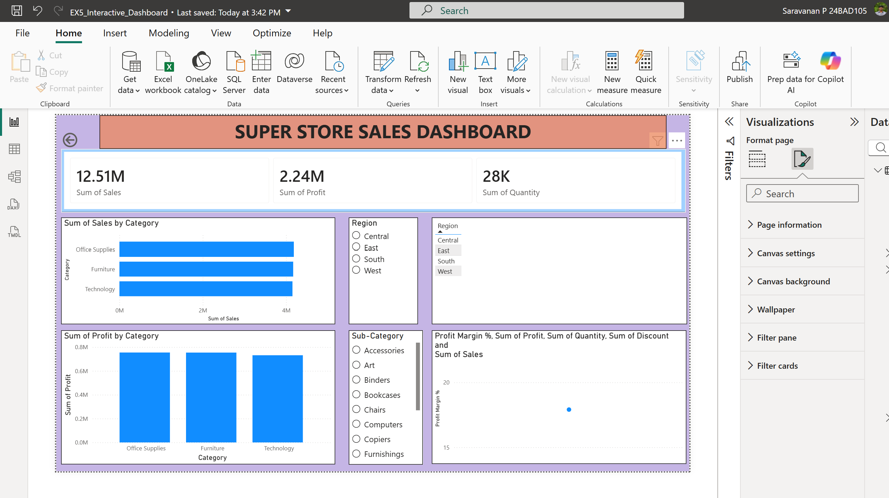

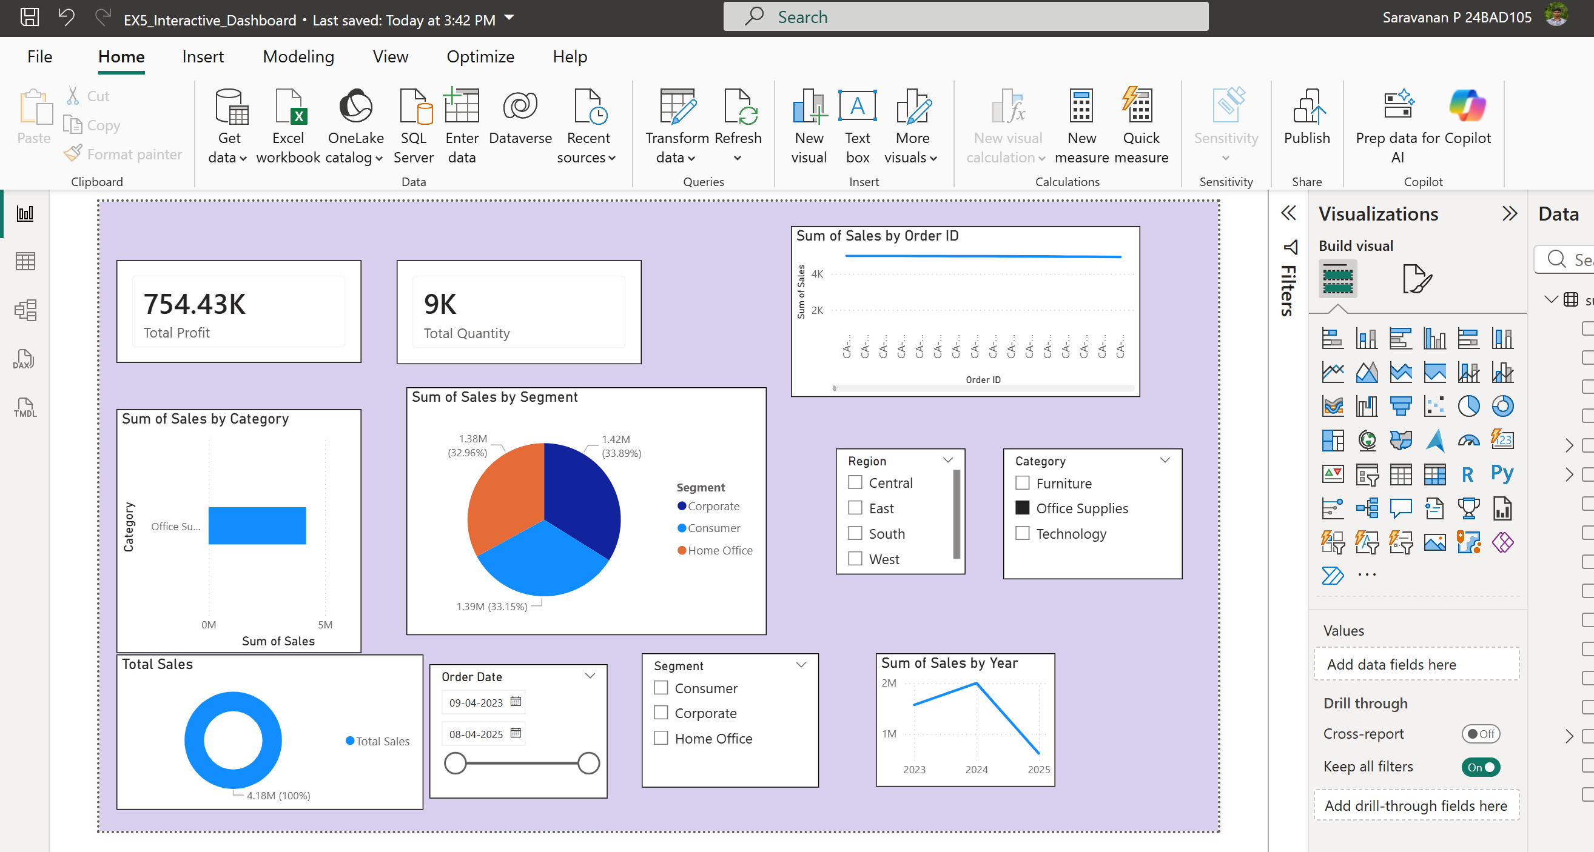

Screenshot:(Tableau)
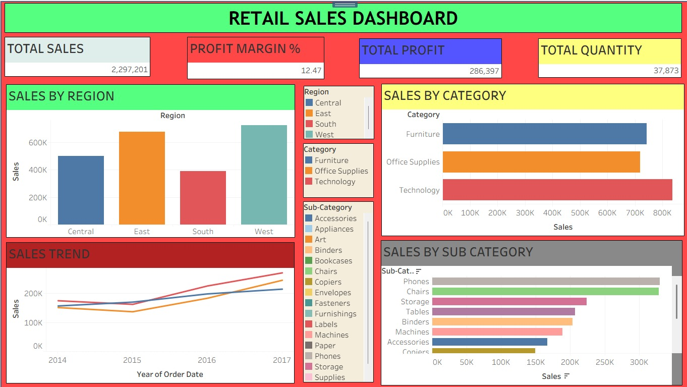

POST-LAB QUESTIONS (PROVIDE BRIEF ANSWERS TO THE FOLLOWING QUESTIONS)
- How did interactivity improve the analysis experience in your dashboard?

Interactivity allowed users to filter data, explore trends, and view detailed information, making the dashboard easier to understand and analyze.

- Which interactive feature (filters, drill-down, parameters, etc.) was most useful and why?

Drill-down was the most useful feature because it enabled detailed analysis by moving from summary-level data to detailed records.

- What challenges did you face while implementing drill-down or dynamic filters?

The main challenges were creating correct hierarchies and ensuring that filters updated all visuals consistently. These were resolved by properly configuring relationships and interactions.

- How do tooltips contribute to better dashboard storytelling?

Tooltips provide additional information when users hover over a data point. They help users understand the data without making the dashboard cluttered.

- What additional features would you add to make the dashboard more insightful?
- Forecasting and trend analysis
- KPI alerts
- Advanced filtering options
- Custom tooltips
- Real-time data updates

RESULT:

The retail sales dataset was successfully transformed, aggregated, and visualized into interactive dashboards in Tableau and Power BI. Filters, slicers, drill-downs, and parameters enabled dynamic exploration of sales and profit trends by region, product category, and time period. The resulting dashboards allowed for quick insights and deeper analysis, enhancing decision-making capabilities.

ASSESSMENT

Description |  | Max Marks | Marks Awarded
Pre Lab Exercise |  | 5
In Lab Exercise |  | 10
Post Lab Exercise |  | 5
Viva |  | 10
 | Total | 30
 | Faculty Signature

